STEGANOGRAPHY BASED TECHNIQUE TO HIDE
INFORMATION WITHIN IMAGE, AUDIO AND VIDEO FILE
Submitted by

Himanshu Tiwari

(20040440012)

Under the guidance of
Mrs. Sunidhi Priyadarshini
(Asst. Prof., Department of Computer Science & Engineering)


Techno India, Polytechnic Compound, Dumka, Jharkhand 814101
Project Report Submitted to
Dumka Engineering College in partial fulfilment
for the award of the degree of

BACHELOR OF TECHNOLOGY
In the department of
Computer Science & Engineering

June 2024

Jharkhand University of Technology, Ranchi


DUMKA ENGINEERING COLLEGE
(Estd. by Govt. of Jharkhand & run by Techno India under PPP) Techno India, polytechnic compound road, Dumka, Jharkhand 814101

CERTIFICATE OF THE SUPERVISOR

Certified that this project titled “STEGANOGRAPHY BASED TECHNIQUE TO HIDE INFORMATION WITHIN IMAGE, AUDIO AND VIDEO FILE” is the
bonafide work of “Himanshu Tiwari (20040440012)” who carried out the project work under my supervision. Certified further, that to the best of my knowledge the work synopsis here in does not from any other synopsis or dissertation on the basis of which a degree or award was conferred on an earlier occasion on this or any other candidate.

Signature Signature
Mrs. Sunidhi Priyadarshini Mr. Ranadeep Dey Assistant Professor Head of the Department Computer Science & Engineering Computer Science & Engineering

DECLARATION

I declare that this written submission represents my ideas in my own words and where others' ideas or words have been included, I have adequately cited and referenced the original sources. I also declare that I have adhered to all principles of academic honesty and integrity and have not misrepresented or fabricated or falsified any idea/data/fact/source in my submission. I understand that any violation of the above will be cause for disciplinary action by the Institute and can also evoke penal action from the sources which have thus not been properly cited or from whom proper permission has not been taken when needed.

…………………………………… Name and Signature of the Student

ACKNOWLEDGEMENT

I would like to express my deepest gratitude to my guide, Mrs. Sunidhi Priyadarshini her valuable guidance, consistent encouragement, personal caring, timely help and providing me with an excellent atmosphere for doing the project. All through the work, in sprit of his busy schedule, she has extended cheerful and cordial support to me for completing this project work.

…………………………………… Name and Signature of the Student

ABSTRACT

Digital Steganography is a smart authentication website. This website provides a registration and login for users. Users can register by giving their necessary details like name, email, phone no., DOB, etc. After successful registration and verification of the user email the user can login by email and password. The user should verify through email OTP verification, so only authenticated users can access the website. The admin can view the request of users and user will be redirected to home page and then user can use our website for performing different types of digital steganography. He/she can also give the feedback according to the performance of our website. The user must be registered and login to use our steganography technique on the basis of their needs. Our website will provide different steganography service to the users, they can directly choose steganography method according to their need. The admin has complete access to user’s login histories on the website.

TABLE OF CONTENTS
CERTIFICATE I
DECLARATION II
ACKNOWLEDGEMENT III
ABSTRACT IV
LIST OF FIGURES V
CHAPTER 1: INTRODUCTION 1-5
  - General 1
  - Motivation 1-2
  - Literature Review 2-3
  - Objectives 3-4
  - Limitations 4-5
CHAPTER 2: RELATED WORK 6-7
  - Overview of Digital Steganography 6-7
  - Existing Research in Digital Steganography 7
CHAPTER 3: WORKING APPROACH FOR PROJECT 8-18
  - TOOLS & TECHNOLOGY USED 8-11
    - Tools 8-9
    - Technology 9-11
  - Hardware and Software Requirements 11-12
  - ER Diagram 13
  - Data Flow Diagram 14-18
CHAPTER 4: IMPLEMENTATION & MODIFICATION 19-23
CHAPTER 5: GLIMPSE OF THE PROJECT 24-36
  - Interface Screenshots 24-34
  - Database Screenshots 35-36

CHAPTER 6: RESULT AND DISCUSSION 37-38

CHAPTER 7: CONCLUSION & FUTURE ENHANCEMENT 39
  - Conclusion 39
  - Future Enhancement 39

CHAPTER 8: REFERENCE 40

 | LIST OF FIGURES
FIGURE NO. | FIGURE NAME | PAGE NO.
3.1 | ER Diagram | 13
3.2 | 0 Level DFD | 14
3.3 | 1 Level DFD | 15
3.4 | Level 2 DFD 1 | 16
3.5 | Level 2 DFD 2 | 17
3.6 | Level 2 DFD 3 | 18
4.1 | Image Array Formation | 19
4.2 | Message Array Formation | 19
4.3 | LSB Operation | 20
4.4 | Audio Array Formation | 20
4.5 | Message Array Formation | 21
4.6 | LSB Operation | 21
4.7 | Video Array Formation | 22
4.8 | Message Array Formation | 22
4.9 | LSB Operation | 23
5.1 | Home Page | 24
5.2 | Signup Page | 24
5.3 | Email Verification | 25
5.4 | Resend OTP | 25
5.5 | OTP Verification | 26
5.6 | Login Page | 27

  - Admin Login 27
  - Main Work 28
  - Image Steganography 28
  - Encode Message 29
  - Decode Message 29
  - Audio Steganography 30
  - Audio Message Encoding 30
  - Message Decoding 31
  - Video Steganography 31
  - Video Message Encoding 32
  - Dashboard 32
  - User Profile 33
  - About Us 33
  - Contact Us 34
  - Database 35
  - User Details 35
  - Stored user activities in admin panel 36
  - Existing super user details 36
  - Output of the Project 38

CHAPTER-1
INTRODUCTION

GENERAL

With the advancement of today’s science and technology, we can’t keep our data and information safe anymore with the help of only encryption. That’s a big reason why steganography was introduced. The main reason to learn and execute steganography is to hide data and information as well as communication. Main focus of steganography is to make our data unreadable and undetectable to an unauthorized user. Steganography provides an additional step that can be used in conjunction with encryption in order to conceal or protect data. This project humbly believes that, steganography decently brings privacy and hide the existence of secret message.
Steganography can be used for both constructive and destructive purposes. For example, education, business institutions, intelligence agencies, etc. The key objectives of steganography include secrecy of communication, invisibility, it often referred to as attackers or steganalysts, to discover the presence of hidden data and ensuring that this method of hiding information is very secure. The scope of steganography is to add extra layer of security during communication by hiding messages within images, audio files and other carriers and to prevent unauthorized copying, or prove authenticity. This technique enhances security measures.

MOTIVATION
Steganography is like a secret code for digital information. It hides important data within ordinary-looking files, like text or images, so that only the intended recipient knows it’s there. This can be used for things like hiding messages in pictures or protecting sensitive information. It’s a way to keep information safe and private.
Here are some motivations for using digital steganography:

    - Privacy Protection: By hiding private information in digital files via steganography, people can safeguard their privacy from unwanted access.

    - Convert Communication: It makes it easier to communicate covertly by hiding messages within ostensibly innocuous cover materials, such pictures or audio files, in order to evade detection.
    - Digital watermarking: To establish content authenticity or confirm ownership, undetectable digital watermarks are embedded into multimedia files using steganography.
    - Data Integrity: To validate the authenticity of files and identify manipulation, checksums or digital signatures are embedded inside them to assure data integrity.
    - Security: Steganography improves security by hiding private information like access codes or encryption keys in digital content, making it more difficult for attackers to intercept or decode.
    - Anonymity: By concealing identifying information inside files, it offers a way for people to converse anonymously without disclosing their identities.
    - Enhancement of Cryptography: Steganography gives encrypted data an additional degree of security by concealing encrypted communications, which is a complement to cryptography.
    - Counter-Forensics: It can be utilized to conceal evidence or private data in digital media, making it more difficult for forensic analysts to find.
    - Political Dissent: Steganography enables people to transmit sensitive material or voice dissent without running the danger of being discovered or persecuted in areas with stringent censorship or surveillance.
    - Historical and Cultural Preservation: To guarantee the long-term authenticity and provenance of cultural heritage objects, steganography is utilized to embed metadata or preservation information within digital artifacts.

LITERATURE REVIEW
Hiding information inside images is a popular technique nowadays. An image with a secret message inside can easily be spread over the World Wide Web or in newsgroups. Use of steganography in newsgroups has been researched by German steganographic expert Niels Provos, who created a scanning cluster which detects the presence of hidden messages inside images that were posted on the net. However, after checking one million images, no hidden messages were found, so the practical use of

steganography still seems to be limited. To hide a message inside an image without changing its visible properties, the cover source can be altered in noisy areas with many colour variations, so less attention will be drawn to the modifications. This is most common method to make these alterations which involves the usage of the least- significant bit or LSB, masking, filtering and transformations on the cover image [1].

Audio steganography involves hiding a secret message in a digitized audio signal with minimal alterations to the audio file. Common methods include:
Least Significant Bit (LSB) alters the least significant bits of audio samples to encode the message It is simple but vulnerable to detection. Phase Coding modifies the phase of audio segments to hide data. Robust but has lower data capacity. Echo Hiding introduces echoes into the audio signal to encode information. Spread Spectrum spreads the secret message across the frequency spectrum. Provides good robustness and security. Each method has strengths and weaknesses, and the choice depends on the specific requirements of the application. [2].

Video steganography embeds a secret message into a video sequence, using techniques from image and audio steganography. The sender uses a video as cover media and can optionally use a secret key 'K' to create a 'stego-video', which is then transmitted to the receiver. The receiver uses the secret key and an extraction algorithm to retrieve the hidden message. The cover video consists of frames Ck(m,n), with 'N' being the total number of frames, and m, n representing pixel coordinates. The binary secret message Mk (m, n) is embedded into the cover video. The stego-video signal is represented as:
𝑆𝑘(𝑚,𝑛)=𝐶𝑘(𝑚,𝑛)+𝑎𝑀𝑘(𝑚,𝑛),
where 'a' is a constant scaling factor [3].

OBJECTIVES
The objective of steganography is to conceal the existence of a message within an innocuous carrier, such as an image, audio, or video file, in such a way that it is difficult for an outsider to detect or decipher the hidden information.

Some of the Basic objectives of steganography are like Confidential Communication, in this the sensitive information concealed within innocent-looking data to prevent interception, Covert Communication means sending secret messages to their existence without alerting unauthorized individuals. Data Hiding within digital media to avoid detection, in information security protecting valuable or classified information from unauthorized access. Steganalysis Resistance is use to creating steganographic techniques that are resistant to detection by adversaries, Digital Watermarking is also embedding for copyright information or ownership details within digital content, the secret key distribution concealing cryptographic keys within innocuous data for secure exchange. It can also be used in anti-forensics for hiding incriminating evidence or metadata within digital files to evade detection during forensic analysis, establishing hidden communication channels for clandestine purposes. The secure data transmission ensures the privacy and integrity of transmitted data over insecure channels.

LIMITATIONS
Like other technologies steganography also has its limitations here are some limitations mentioned:
    - Detection: Advanced forensic analysis technologies are capable of detecting steganography methods.
    - Limited Capacity: There is a maximum amount of data that may be concealed in a picture or file.
    - Compression Susceptibility: When the carrier file is compressed, steganographic data could be lost or changed.
    - Security Risks: The concealed data is readily accessible in the event that the steganographic key is compromised.
    - Complicated Encoding/Decoding: The encoding and decoding of certain steganographic techniques call for complicated algorithms.
    - Sensitivity to Noise: The concealed data may be distorted by outside influences like noise or interference.
    - Limited File Types: Not all file formats or types can use steganography.
    - Compatibility Problems: Data that is hidden could not be available on other platforms or software.

    - Attack Vulnerability: Specific attacks focused at extracting secret data can target steganographic methods.
    - Performance Overhead: Systems may have performance overhead as a result of embedding and extracting hidden data.

CHAPTER-2
RELATED WORK

OVERVIEW OF DIGITAL STEGANOGRAPHY

One method for concealing secret information from other non-secret data is digital steganography. This can involve incorporating text, pictures, or even video into other files in a way that makes it invisible to users who aren’t seeking for it. Steganography’s main objective is to hide the concealed message’s presence, making it harder for outsiders to find or interpret the data. Using a carrier file is one of the digital steganography’s fundamental ideas. The hidden message is contained in this file. Picture, audio, and video files are common carrier file formats. The carrier file contains the hidden message encoded by means of a steganography method. Depending on the kind of carrier file and necessary level of security, different algorithms may be chosen.
For instance, in image steganography, the hidden message is frequently inserted into the pixels that have the least amount of significance. These parts can be changed without drawing too much attention to themselves because they don’t significantly affect the image’s overall appearance. Similar principles apply to audio steganography, where the secret message is encoded into the audio samples. Making sure the intended recipient can recover the hidden message error-free is one of the main issues in digital steganography. Error detection and correction methods must be used in order to prevent the secret message from being lost or corrupted during transmission. An additional crucial factor in digital steganography is the ability of unapproved parties to detect concealed messages. Steganalysis is the process of examining the carrier file to search for indications of alteration. Among the steganography approaches are statistical analyses of the file data, which involve searching for anomalies that can point to the existence of a concealed message.
One of the most popular uses is in covert communication, which allows two people to communicate covertly and undetected. Digital watermarking, in which information is placed in a file to identify its owner or source, is another application for steganography. Steganography can also be used to conceal private data, such encryption keys, inside of other files to prevent unauthorized access. The uses for digital steganography are

numerous. One of the most popular uses is in covert communication, which allows two people to communicate covertly and undetected. Digital watermarking, in which information is placed in a file to identify its owner or source, is another application for steganography. Steganography can also be used to conceal private data, such encryption keys, inside of other files to prevent unauthorized access.
To sum up, digital steganography is an effective method for concealing sensitive information from view among other data. Steganography is the process of encoding messages into text, audio, video, or image files in order to conceal communication and safeguard private data. Nevertheless, finding concealed messages continues to be difficult and necessitates the application of sophisticated steganalysis methods.

EXISTING RESEARCH IN DIGITAL STEGANOGRAPHY
Existing research in digital steganography spans a variety of techniques and methods, with a focus on enhancing security, robustness, and imperceptibility. Recent studies have explored various approaches, such as LSB (Least Significant Bit) substitution methods, which involve embedding secret data in the least significant bits of image pixels. These methods have been enhanced by incorporating encryption algorithms like AES (Advanced Encryption Standard) for added security.
Other research includes 3D geometric model steganography, which embeds data into the vertices of triangular meshes, making it resistant to affine transformations like cropping and scaling. Additionally, adaptive schemes have been developed to select embedding regions based on pixel differences or image content, improving both security and data hiding capacity. Techniques such as edge-adaptive schemes, histogram-based reversible data hiding, and randomization techniques using RGB values have also been proposed to further enhance the robustness and imperceptibility of steganographic methods. Overall, these advancements highlight the continuous efforts to improve the effectiveness and security of digital steganography [4].

CHAPTER-3
WORKING APPROACH FOR PROJECT

TOOLS & TECHNOLOGY USED
In this project tools and technologies which are used, Visual Studio Code as our source code editor. Languages such as HTML, CSS, BOOTSTRAP, PYTHON, DJANGO have been used.

TOOLS

- Visual Studio Code

Visual Studio Code is a versatile, free coding editor that supports various programming languages, allowing you to start coding quickly without needing to switch editors. It provides a convenient environment for coding in languages like Python, Java, C++, JavaScript, and many others.

Benefits of Visual Studio

Microsoft’s product is designed to simplify the complex process of creating applications by offering a wide range of features and tools. It allows developers to test applications and fix errors in real-time, making the development process more efficient. Additionally, it offers convenient navigation features, making it easier for developers to move between different parts of their codebase.

Some Features of Visual Studio

  - Command Line
Visual Studio Code’s command line interface allows you to customize how you start the editor. You can use it to open specific files, install extensions, and set the display language, among other things, giving you more control over your development environment.

  - Debugging
he built-in debugger in Visual Studio Code allows developers to efficiently debug their code directly within the editor, providing a seamless and integrated debugging experience.

  - Snippets
Visual Studio Code’s snippets feature provides predefined code templates that help developers quickly insert common or boilerplate code segments, reducing the need for manual typing and speeding up the coding process. Users can also create custom snippets to match their coding patterns and preferences.

  - Live Share
Live Share in Visual Studio Code allows multiple developers to collaboratively edit and debug code in real-time, providing a shared environment where users can see each other’s cursors and edits. It supports shared debugging sessions, enabling efficient remote teamwork regardless of physical location.

  - Integrated Terminal
Visual Studio Code features an integrated terminal that allows developers to execute shell commands and manage their projects without leaving the editor. This built-in terminal provides a convenient way to perform various tasks, such as running scripts, installing dependencies, or interacting with version control systems, enhancing the overall development workflow [5].

TECHNOLOGIES

      - HTML
HTML stands for Hyper Text Markup Language. It is the standard markup language used to create web pages. HTML is a combination of Hypertext and Markup language. Hypertext defines the link between web pages. A markup language is used to define the text document within the tag to define the structure of web pages [6].

CSS
CSS (Cascading Style Sheets) is a simply designed language intended to simplify the process of making web pages presentable. CSS allows you to apply styles to HTML documents. It describes how a webpage should look. It prescribes colors, fonts, spacing, etc. In short, you can make your website look however you want. CSS lets developers and designers define how it behaves, including how elements are positioned in the browser [7].

BOOTSTRAP
Bootstrap is a popular open-source framework for front-end web development. It offers a variety of HTML, CSS, and JavaScript components and tools that help developers create responsive, mobile-friendly websites quickly and easily. With Bootstrap, you can efficiently design and customize the layout and appearance of your web pages to ensure they look great on all devices [8].

PYTHON
Python is one of the easiest yet most useful programming languages which is widely used in the software industry. People use Python for Competitive Programming, Web Development, and creating software. Due to its easiest syntax, it is recommended for beginners who are new to the software engineering field. Its demand is growing at a very rapid pace due to its vast use cases in Modern Technological fields like Data Science, Machine learning, and Automation Tasks [9].

DJANGO
Django is a Python-based web framework which allows you to quickly create web application without all of the installation or dependency problems that you normally will find with other frameworks. When you’re building a website, you always need a similar set of components: a way to handle user authentication (signing up, signing in, signing out), a management panel for your website, forms, a way to upload files, etc. Django gives you ready-made components to use [10].

HARDWARE & SOFTWARE REQUIREMENT

SOFTWARE REQUIREMENTS:

      - Operating System:
Operating Systems are essential for steganography because they provide the foundational environment and resources for steganographic tools to function. The operating system required for digital steganography project with LSB method can be windows 7 or above. They offer the platform on which steganography software can run, manage file systems crucial for hiding information, provide security features that impact steganography, manage networking for network-based steganography, and handle resource management for efficient steganographic operations. Without an operating system, steganographic tools would not have the necessary environment to operate effectively.

      - Python 3.6 or above
Python is a popular programming language in the field of steganography due to its simplicity, readability, and the availability of libraries that facilitate steganographic techniques. Some specific uses of Python in steganography Python’s versatility and ease of use make it a popular choice for implementing steganographic techniques and developing steganography tools. Python is used in steganography for implementing steganographic algorithms, Processing and manipulating images, audio, and text, which are common carriers for hidden messages and ensuring cross-platform compatibility of steganographic tools.
Taking advantage of its rich ecosystem of libraries for various steganographic tasks like leveraging its simplicity and readability for easy understanding and modification of steganography code.

      - Browser (Google Chrome | Microsoft Edge)
Browser’s features make it a suitable platform for implementing and accessing steganography techniques through websites. Some of the Basic features of Browser Rendering and Display: Chrome’s rendering engine displays web

content, including images and videos, which can be carriers for hidden messages in steganography.

HARDWARE REQUIREMENTS:

      - Processor: Intel Core i3 or above
      - Hard Disk: 4GB or above
      - Memory: 1GB RAM
      - Internet Connection


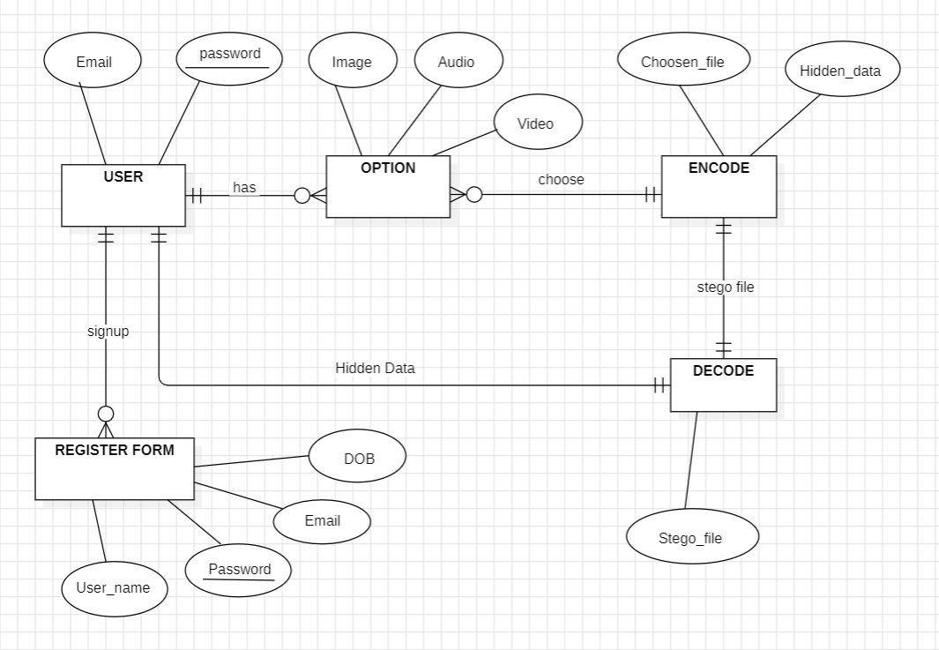
ER DIAGRAM

Fig 3.1: ER DIAGRAM


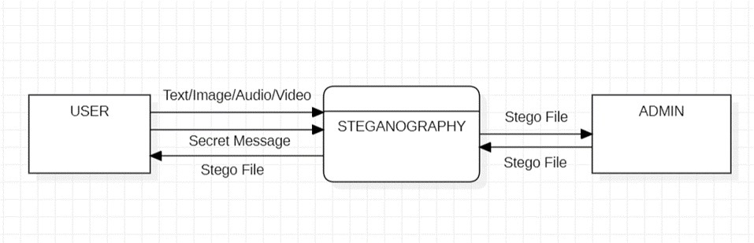
3.3 DATA FLOW DIAGRAM

0-Level DFD:

Fig 3.2: 0-Level DFD for Digital Steganography

The 0 level DFD explain or give us very basic information about the software we are creating. It provides the idea of single process and some entities which are involved in this process.
Process –
- Steganography

Entity –
- User
- Admin


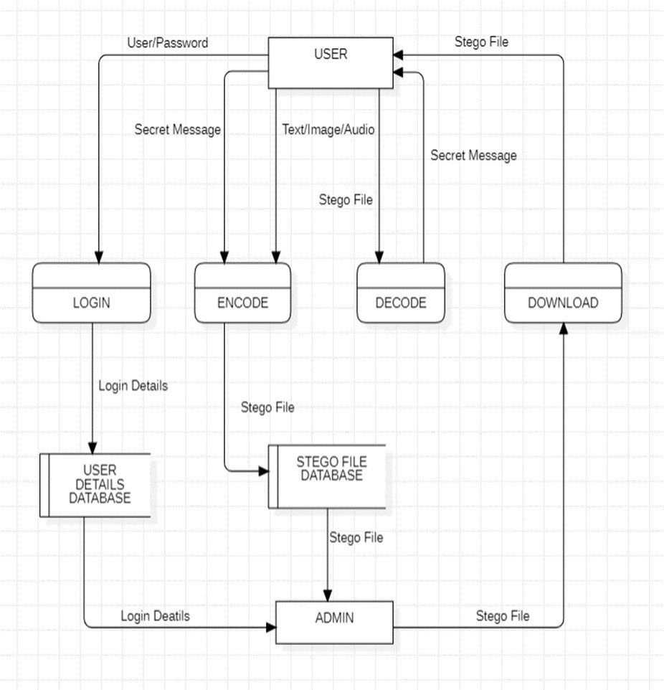
- Level DFD:

Fig 3.3: 1-Level DFD for Steganography

In Level 1 DFD have detail description of the main process with combination of required database and entities with proper data flow.
Process –
- Login
- Encode


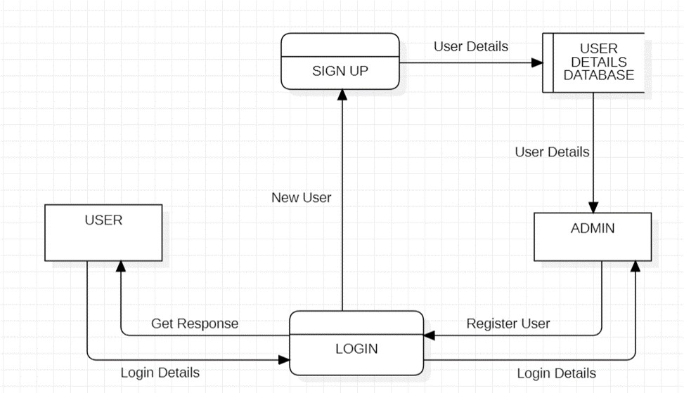
- Decode
- Download
Entity –
- User
- Admin

Database –
- User Details Database
- Stego File Database

- Level DFD:

Login Process:

Fig 3.4: Login Process is expended in details in 2-Level DFD


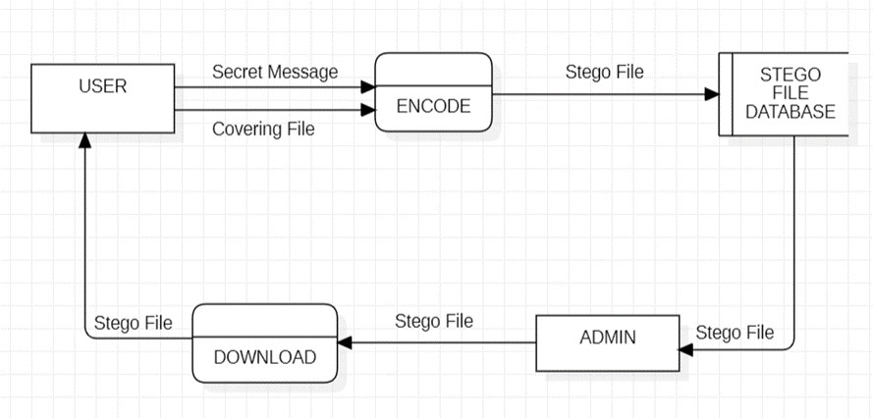
Encode Process:

Fig 3.5: Encode Process is expended in details in 2-Level DED

In Level 2 DFD the process explained in level -1 are explained in more detail and depth.
Process –
- Login
  - Signup
  - Login
- Encode
  - Download

Entity –
- User
- Admin

Database –
- User Details Database
- Stego File Database


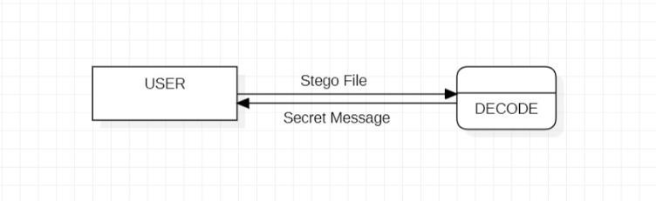
Decode Process:

Fig 3.6: Decode Process

In Level 2 DFD the process explained in level -1 are explained in more detail and depth.

Entity –
1. User

Process –
1. Decode

CHAPTER-4
IMPLEMENTATION & MODIFICATION

IMPLEMENTATION OF IMAGE STEGANOGRAPHY
There are two methods in image steganography:
    - Spatial Method
    - Transform Method

Among this two we are using Spatial method. In spatial method LSB (Least Significant Bit) substitution method is used it is a common simple approach used to embedding information in a cover file. It converts the image bit in pixel and the text in binary format and alter the LSB bit to embed the text in image and provide stego image which consist of hidden message.

Step 1: Formation of Image array
In this, all pixels from the given image are stored in array format, where each pixel contains information about its color or grayscale value (RGB).
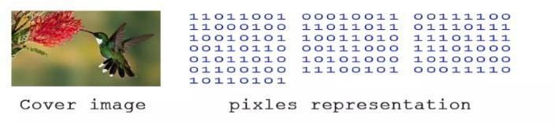
Fig 4.1: Image Array Formation

Step 2: Formation of Message array
All the binary bit from the given text file is extracted and stored in array format.
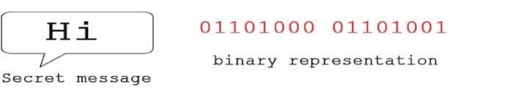

Fig 4.2: Message Array Formation

Step 3: LSB Operation
In this, place character of message array in each component of image array by replacing its LSB bit
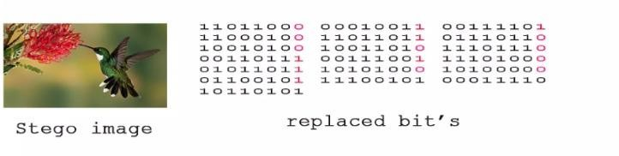
Fig 4.3: LSB Operation

The image obtained after replacing all the bits will give us a stego image in which the secret message is hidden inside the image.

IMPLEMENTATION OF AUDIO STEGANOGRAPHY
There are different methods of audio steganography.
    - LSB Coding
    - Phase Coding
    - Spread Spectrum

In audio steganography, a secret message is hidden in an audio file by making tiny changes to its digital data. Among this three we use LSB Coding, which converts the audio bit and the text in binary format and alter the LSB bit to embed the text in audio and provide stego file which consist of hidden message.

Step 1: Formation of Audio array
In this, all binary bits are extracted from the given audio file and store in array format.
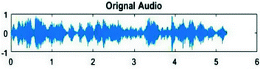
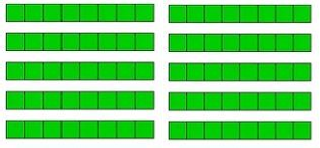
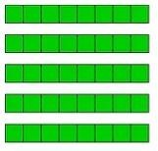
Cover Audio Binary Representation

Fig 4.4: Audio Array Formation

Step 2: Formation of message array
All the binary bit from the given text file is extracted and stored in array format.
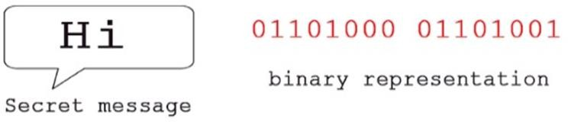

Fig 4.5: Message Array Formation

Step 3: LSB Operation
In this, place character of message array in each component of audio array by replacing its LSB bit.
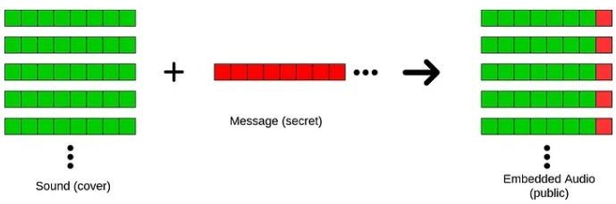
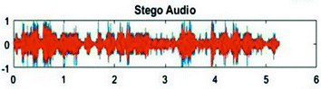

Fig 4.6: LSB Operation

IMPLEMENTATION OF VIDEO STEGANOGRAPHY
There are different methods of Video Steganography
    - Least Significant Bit (LSB)
    - Masking and filtering
    - Transform based

In video steganography, a secret message is hidden in an video file. Among this three we use LSB Coding, which converts the video bit and the text in binary format and alter the LSB bit to embed the text in video and provide stego file which consist of hidden message.

Step 1: Formation of Video array
In this, all binary bits are extracted from the given video file and store in array format.

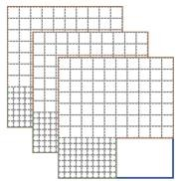
Cover Video Binary Representation

Fig 4.7: Video Array Formation

Step 2: Formation of message array
All the binary bit from the given text file is extracted and stored in array format.
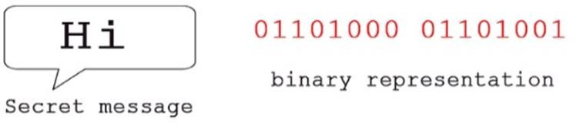
Fig 4.8: Message Array Formation

Step 3: LSB Operation
In this, place character of message array in each component of video array by replacing its LSB bit.

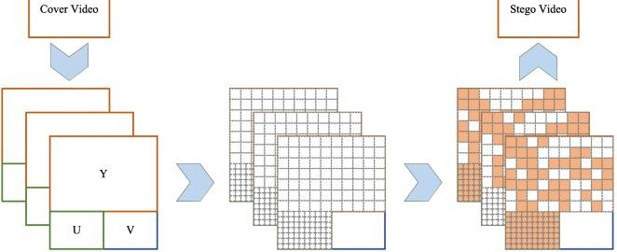
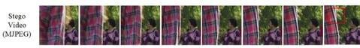

Fig 4.9: LSB Operation

CHAPTER-5 GLIMPSE OF PROJECT

INTERFACE SCREENSHOT

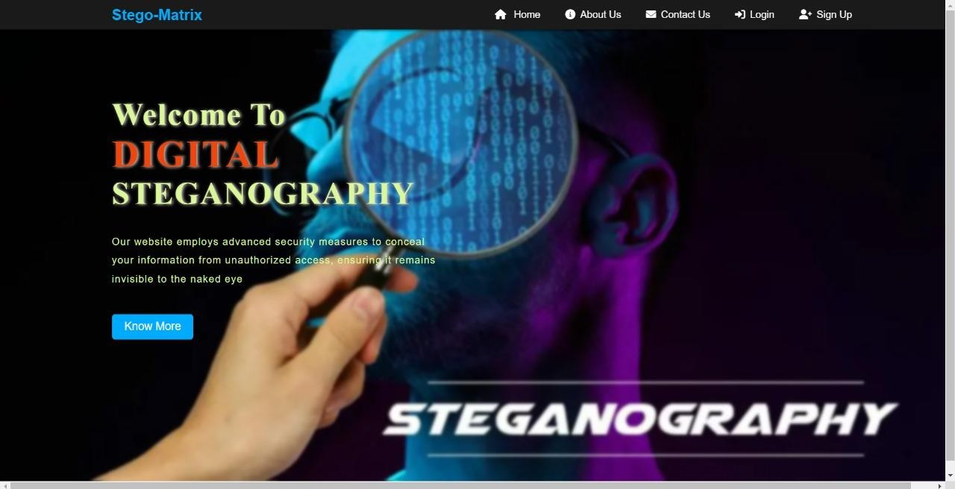

Fig 5.1: Home Page

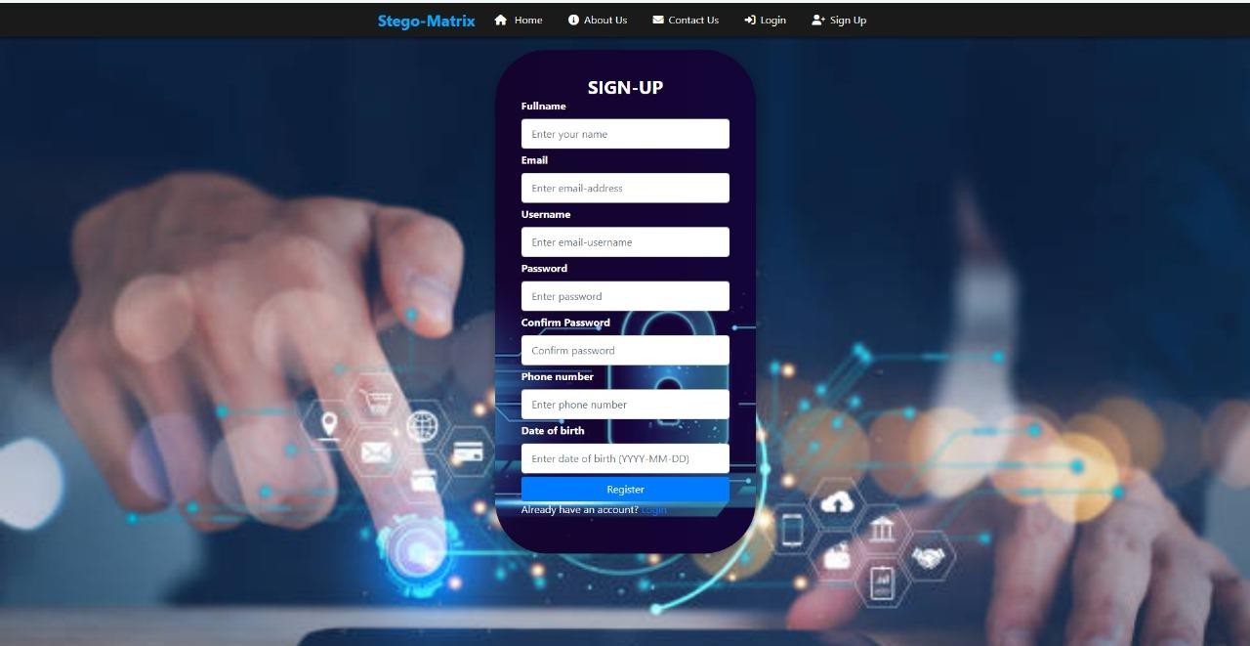

Fig 5.2: Signup Page

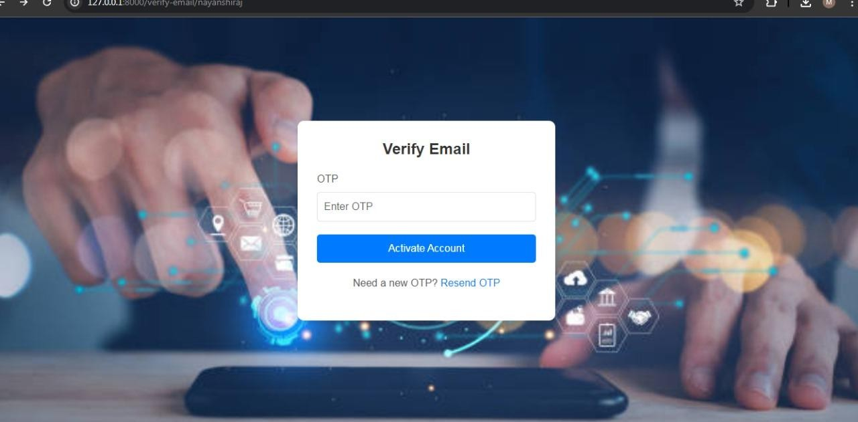

Fig 5.3: Email Verification

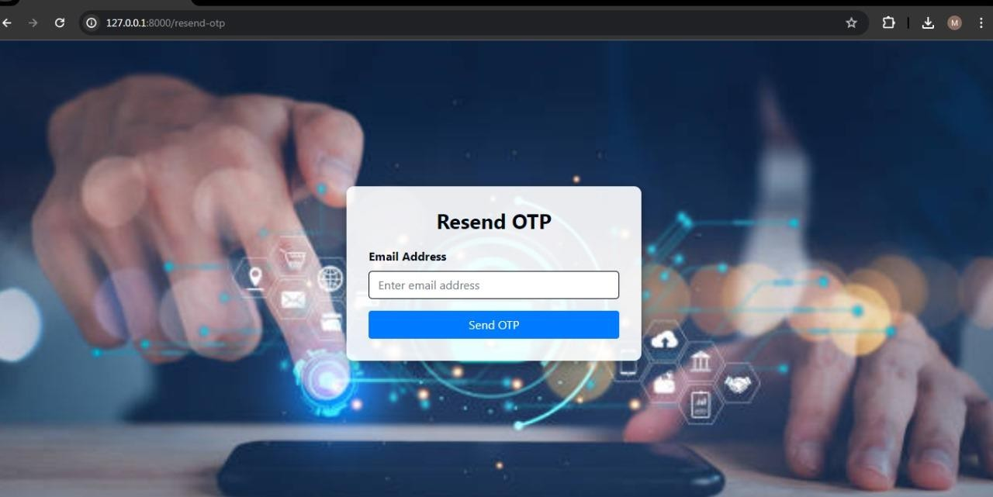

Fig 5.4: Resend OTP

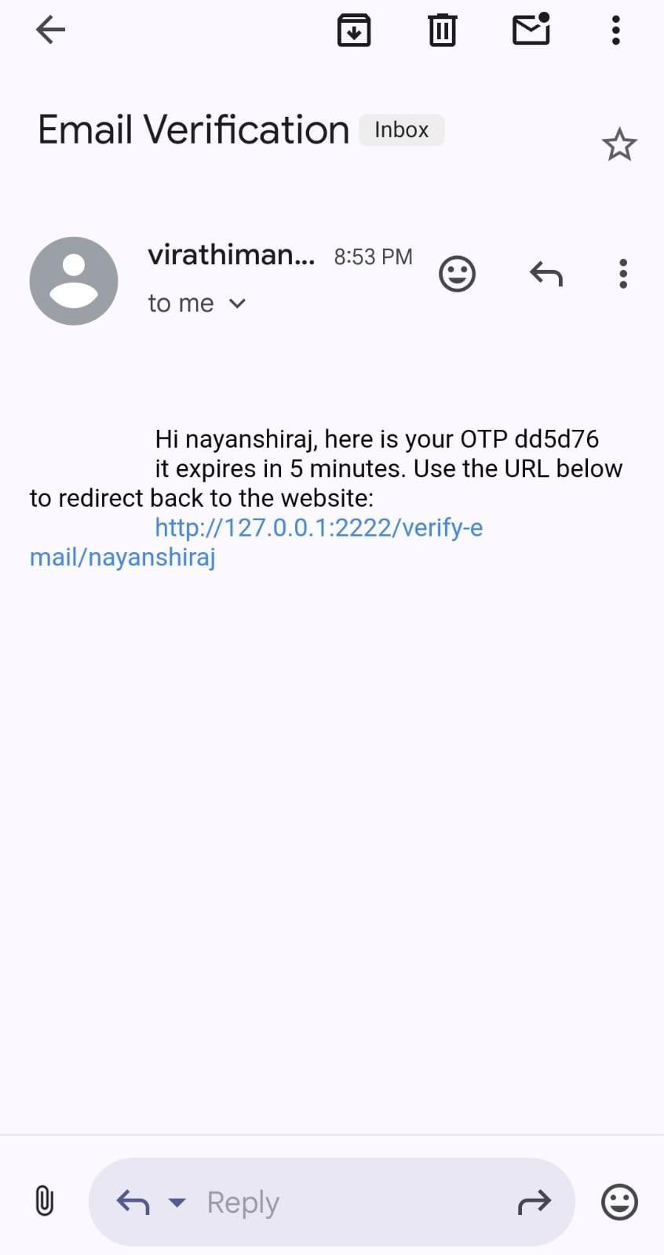

Fig 5.5: OTP Verification

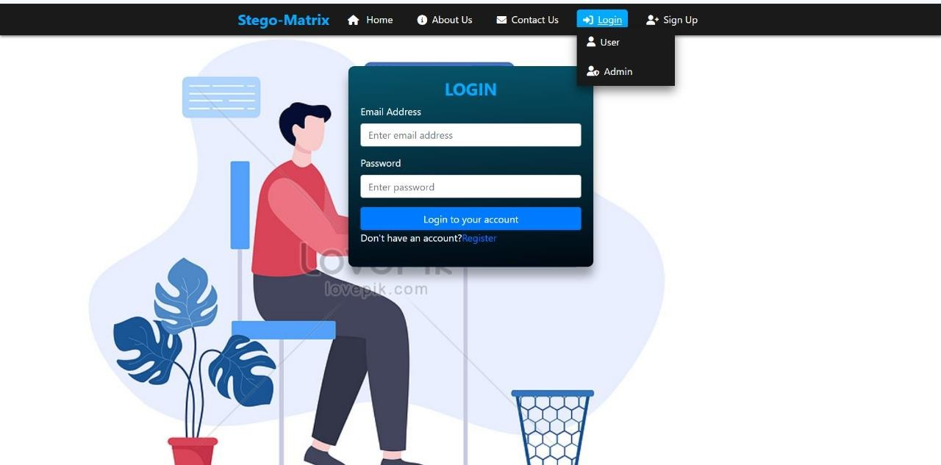

Fig 5.6: Login Page

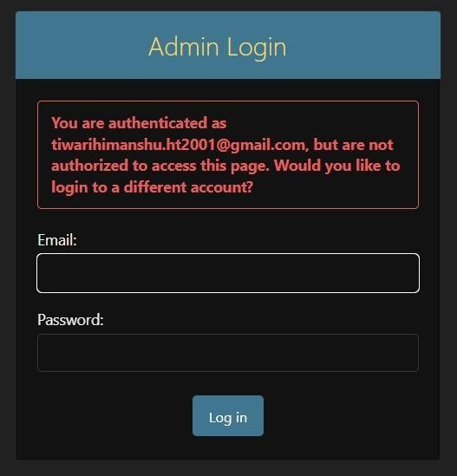

Fig 5.7: Admin Login

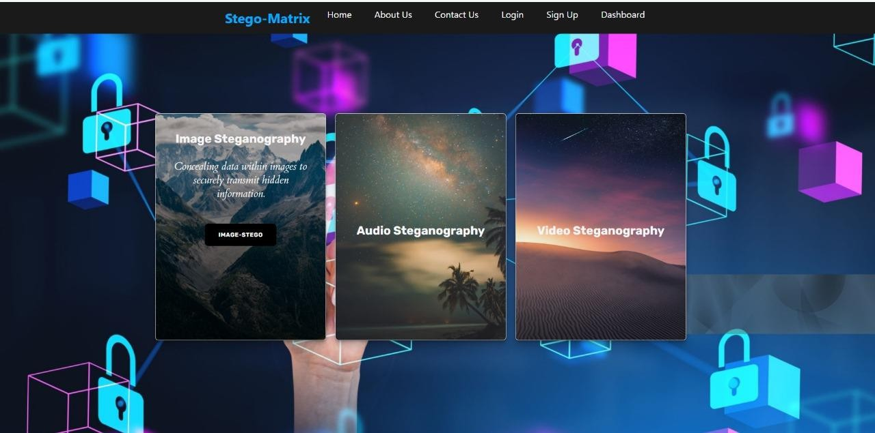
Fig 5.8: Main Work

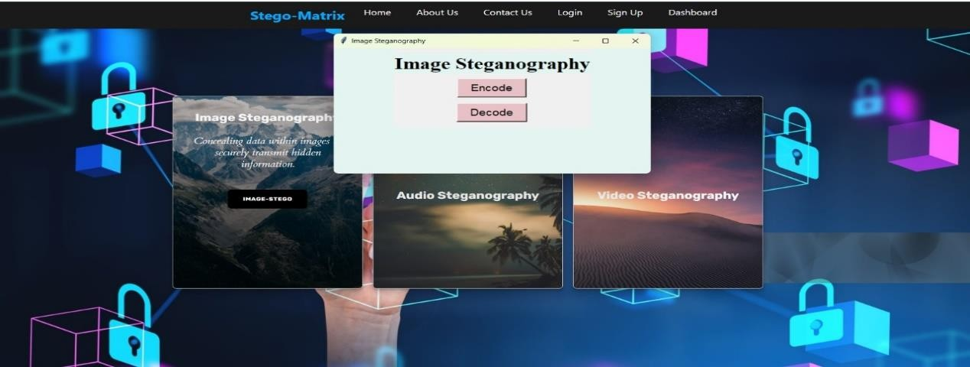

Fig 5.9: Image Steganography

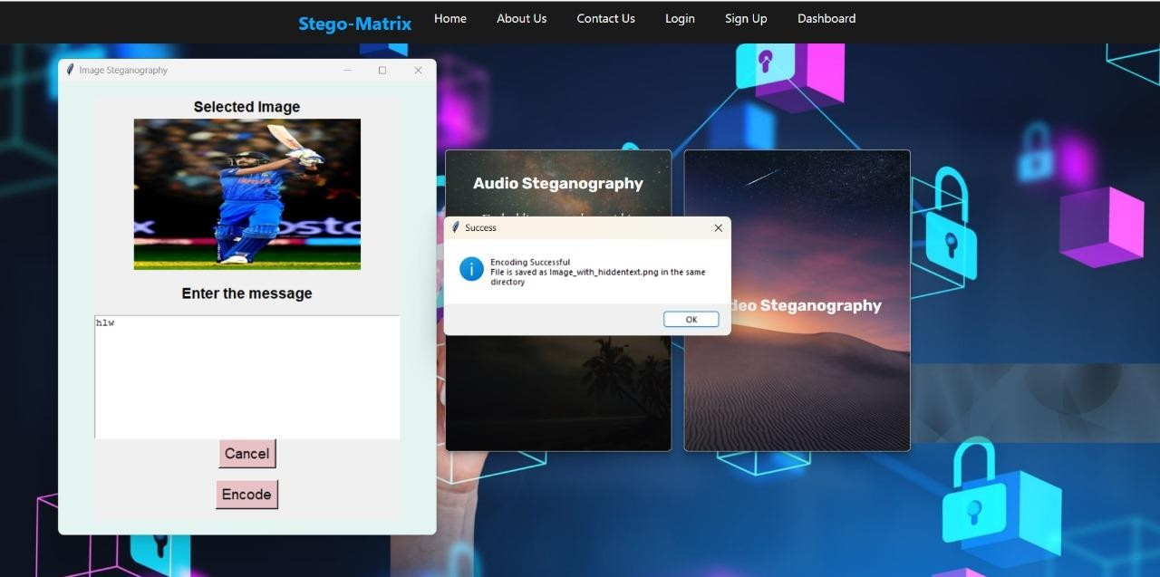

Fig 5.10: Encode Message

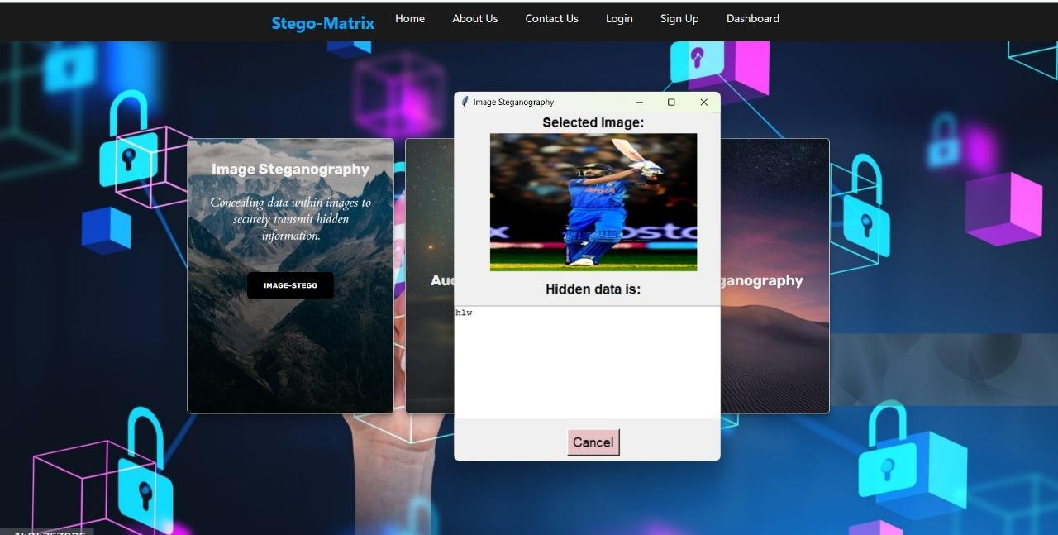

Fig 5.11: Decode Message

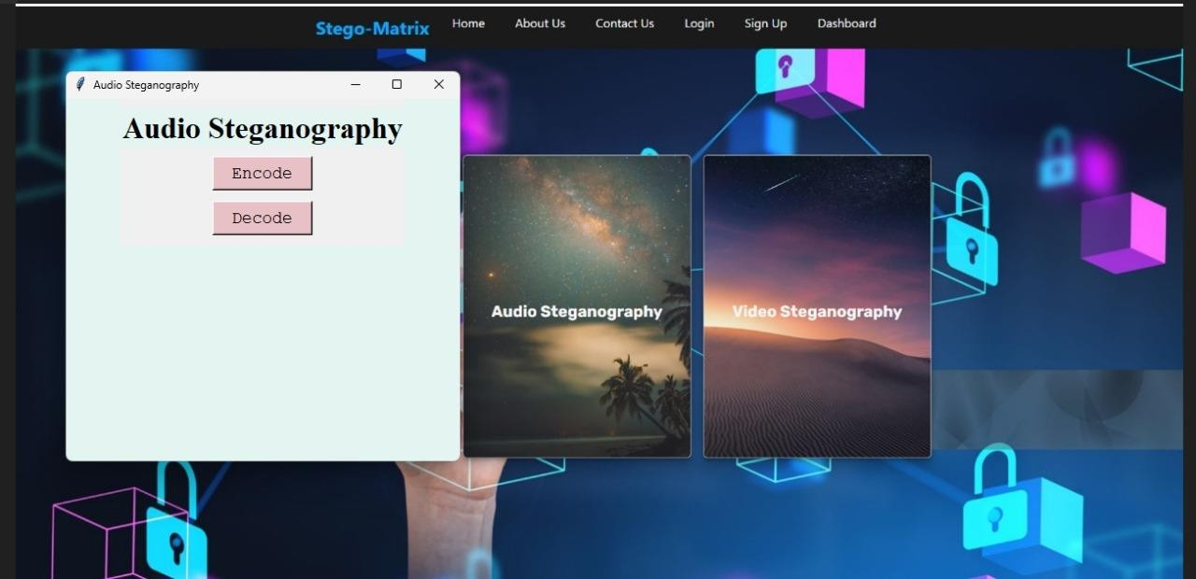

Fig 5.12: Audio Steganography

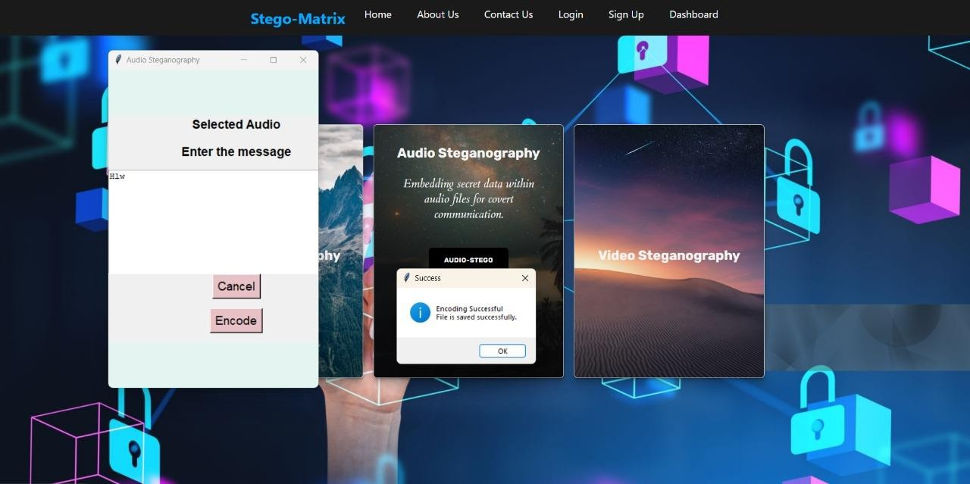

Fig 5.13: Audio Message Encoding

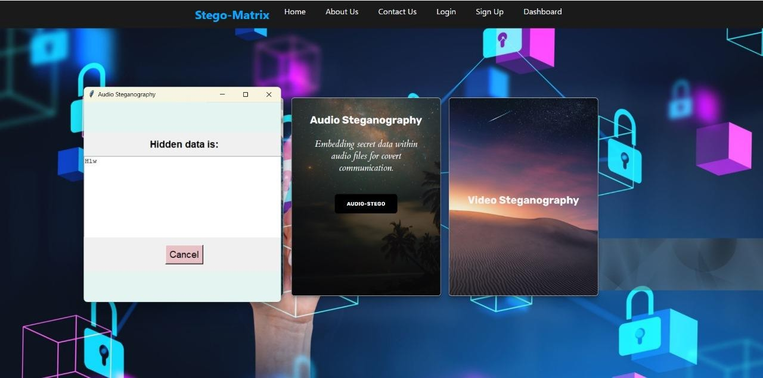
Fig 5.14: Message Decoding

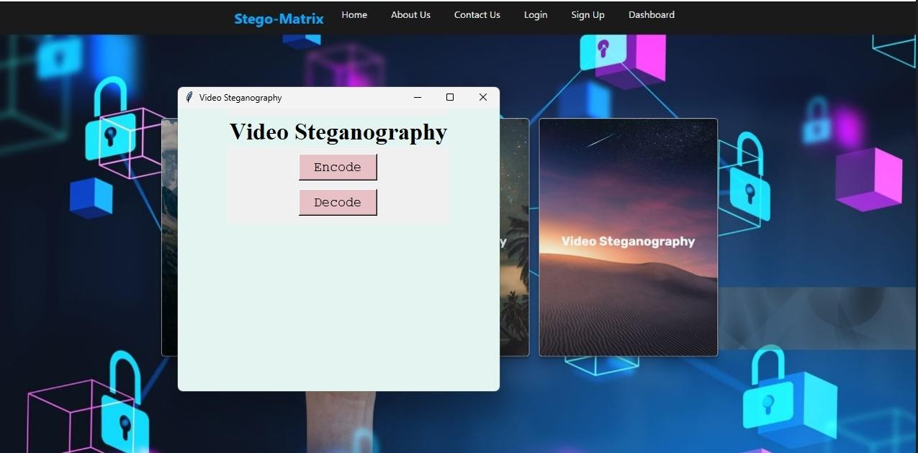

Fig 5.15: Video Steganography

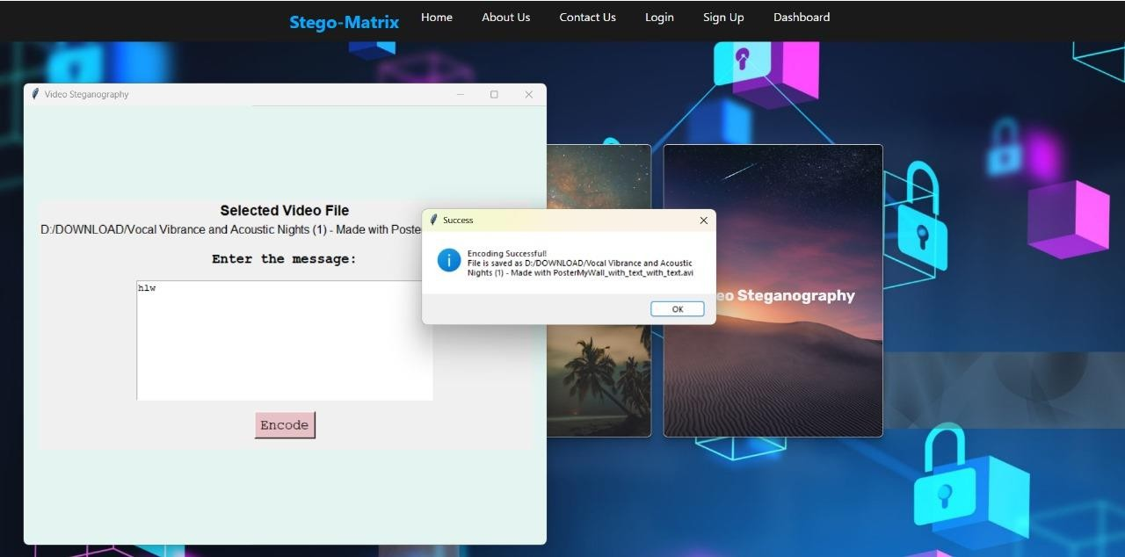

Fig 5.16: Video Message Encoding

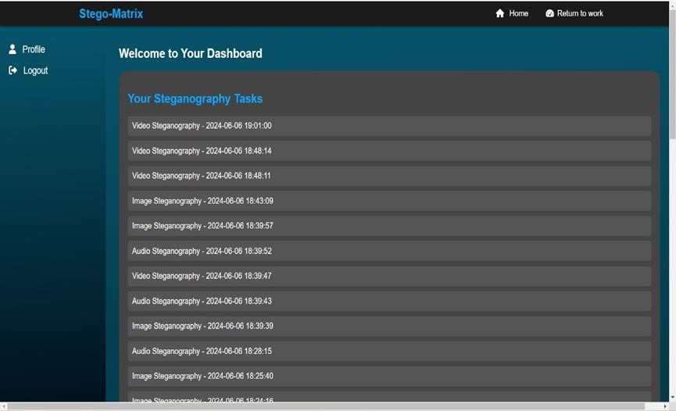

Fig 5.17: Dashboard

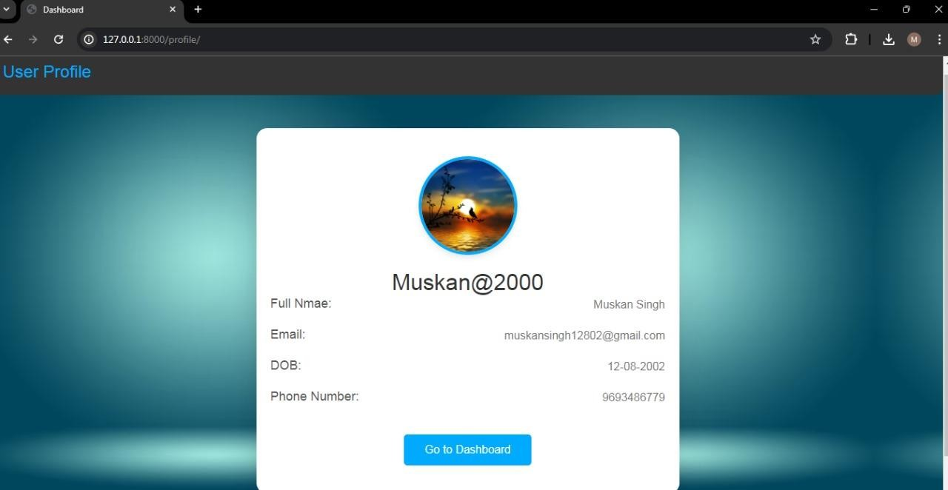
Fig 5.18: User Profile

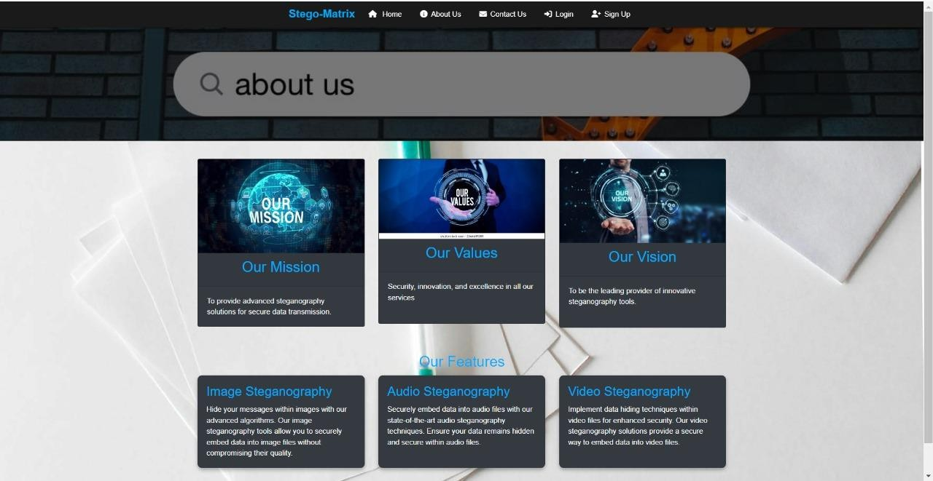

Fig 5.19: About Us

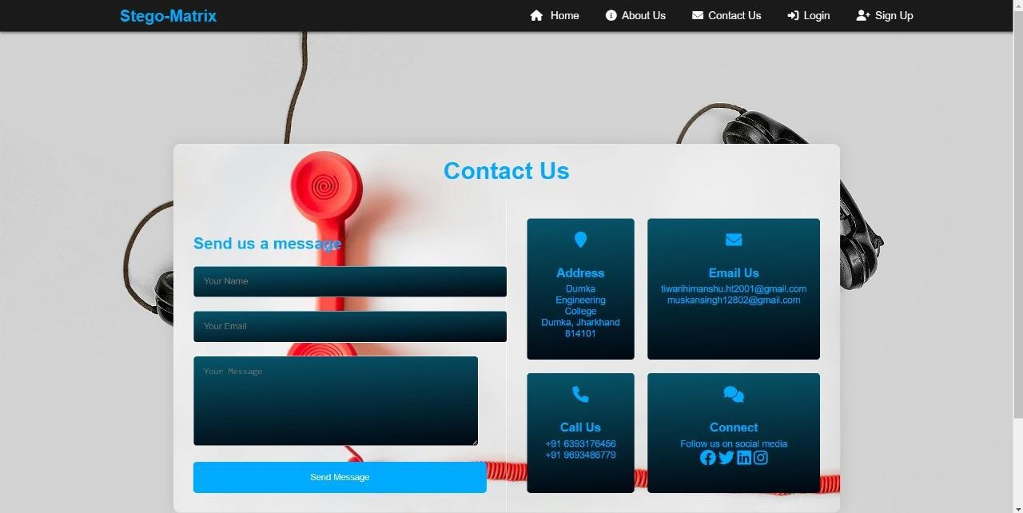
Fig 5.20: Contact Us

DATABASE SCREENSHOT
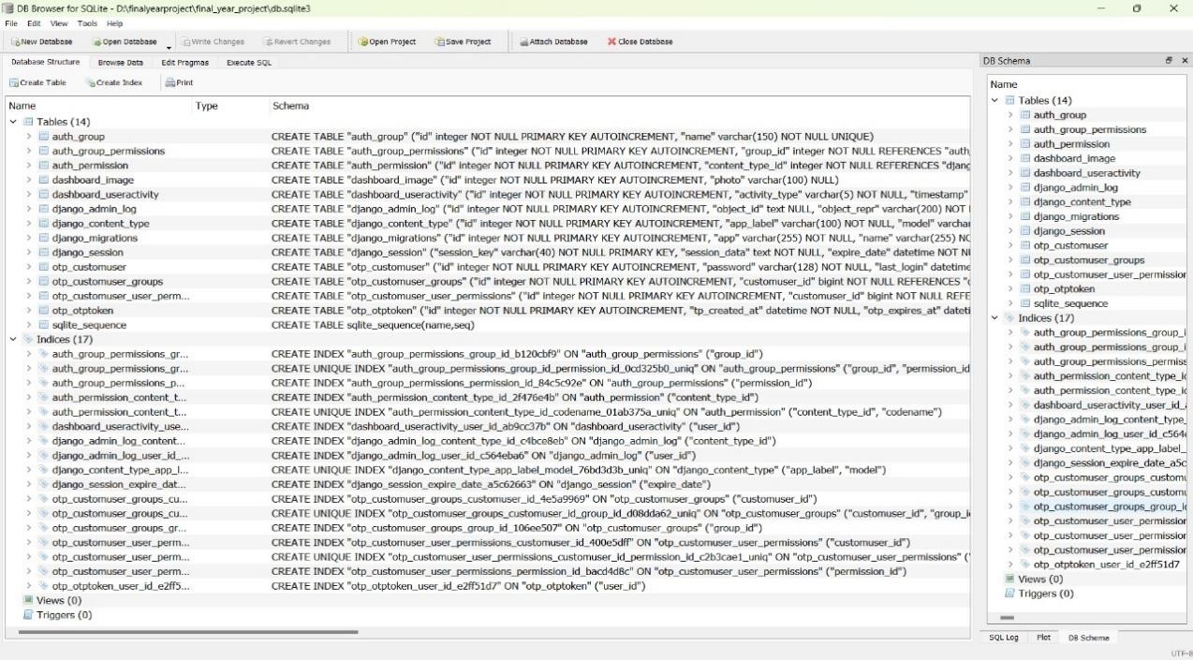

Fig 5.21: Database

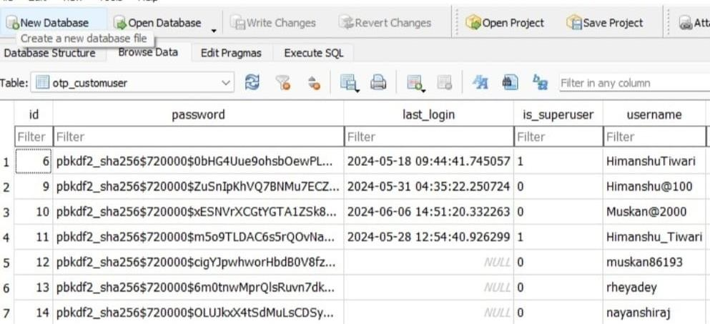
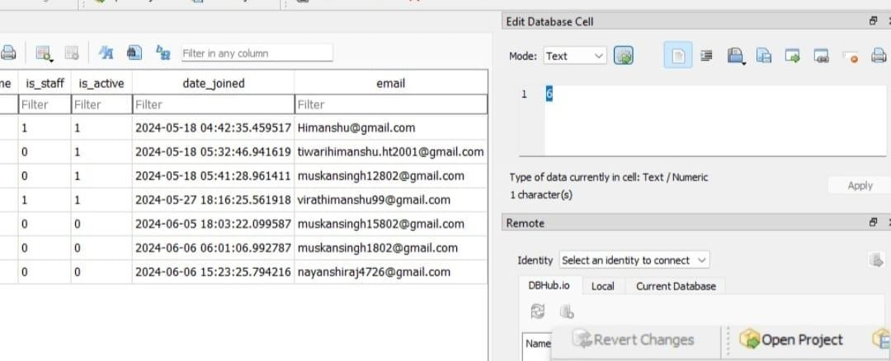

Fig 5.22: User Details

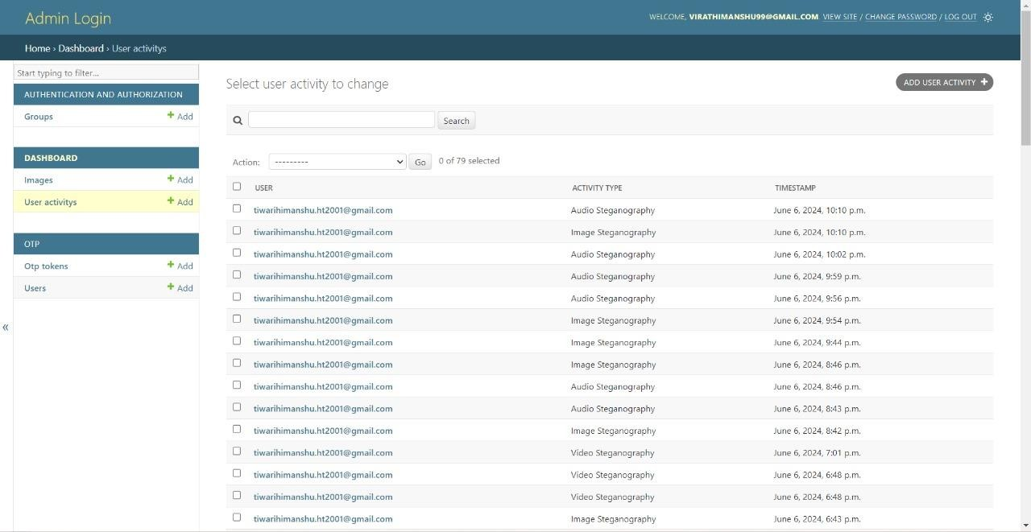

Fig 5.23: Stored user activities in admin panel

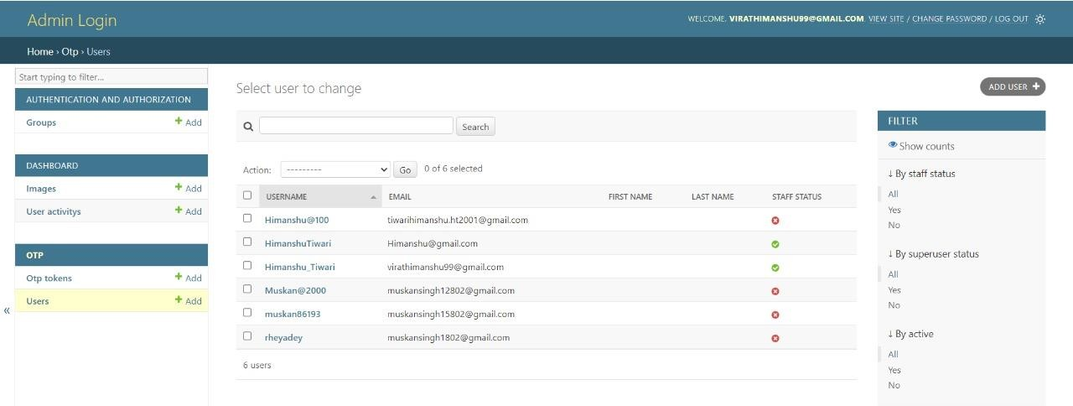

Fig 5.24: Registered User

CHAPTER 6
RESULT AND DISCUSSION

In this digital steganography project, the main focus on implementing image, audio, and video steganography using the Least Significant Bit (LSB) technique. The goal is to develop a robust system capable of securely embedding data into multimedia files and storing them locally. By embedding data into the least significant bits of media files, and this ensure minimal perceptual differences from the original files, making the hidden data undetectable to human senses.
For the encoding process, users can choose a file from their local storage and add the data they want to conceal. The system then embeds the hidden data into the chosen file, creating a stego file. This stego file contains the concealed data in a way that is invisible to the naked eye.
To decode, users can choose a file from their local storage to extract and retrieve the hidden data. This feature ensures that data can be securely embedded and accessed when needed. The project is built with the Django framework, which seamlessly integrates backend logic with a user-friendly frontend. This design makes it easy for users to interact with the steganography system, making encoding and decoding processes simple and accessible.
This project shows how the LSB technique can be used with different media types to securely transmit data. Using Django, the website is made functional and easy to use, helping people understand and engage with digital steganography. It highlights how steganography can improve data security and privacy in digital communication.



Fig 6.1: Output of the Project

CHAPTER-7
CONCLUSION & FUTURE ENHANCEMENT

CONCLUSION
In conclusion, the use of steganography can be beneficial as it offers a way to secure data and communication covertly. It can provide an extra layer of security by hiding the existence of sensitive and useful information in military and other secretive operations. It can also be used for embedding invisible watermarks to protect intellectual property by hiding messages within innocent-looking files.

It is the practice of hiding information inside things like images, audio files, video files, or text to keep it safe and secret. It is used for secure communication, protecting digital copyrights, and secret operations in cybersecurity, in future, combining steganography with artificial intelligence and developing new methods for a world with quantum computing will be important. Overall, steganography is a key tool for keeping data secure, and ongoing research is needed to make it even better.

FUTURE ENHANCEMENT
As technology advances this field will likely continue to evolve with new method, challenges and applications and in upcoming future some fields where we will try to implement steganography technique are:
    - Implementing multilayer steganography on a website will enhance security by embedding multiple layers of hidden data within a single file, making it much harder for unauthorized individuals to detect and access the concealed information.
    - Steganography will be used in various applications to hide data in files or streams, boosting security. Along with encryption and secure communication tools, this will ensure data remains protected even if one security measure fails.
    - In this project, the decoding of video will be processed in the future.

CHAPTER-8 REFERENCE

- https://www.ijcsit.com/docs/Volume%206/vol6issue01/ijcsit20150601152.pdf
- https://www.researchgate.net/publication/334327646_Audio_Steganography-
A_Review
- https://www.academia.edu/37085643/Review_on_Video_Steganography
- https://ieeexplore.ieee.org/iel7/6287639/8948470/09187785.pdf
- https://www.educative.io/answers/what-is-visual-studio-code
- https://developer.mozilla.org/en-US/docs/Web/HTML
- https://developer.mozilla.org/en-US/docs/Web/CSS
- https://getbootstrap.com/
- https://docs.python.org/3/
- https://docs.djangoproject.com/en/5.0/
- https://staruml.io/

